SUPPLEMENT
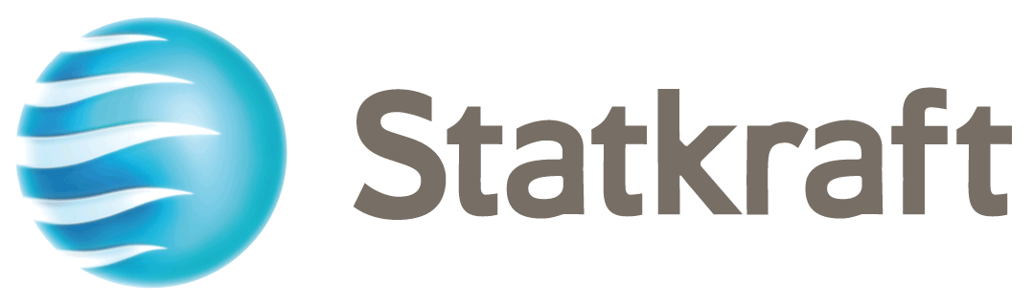

STATKRAFT AS

(a limited company registered under number 987 059 699 with the
Norwegian Register of Business Enterprises)

€6,000,000,000

Euro Medium Term Note Programme

This supplement (the “Supplement”) is prepared in connection with the €6,000,000,000 Euro Medium Term Note Programme (the “Programme”) established by Statkraft AS (the “Issuer”).
This Supplement is a supplement to the offering circular dated 29 March 2021 (the “Offering Circular”). The Offering Circular constitutes a base prospectus under Article 8 of Regulation (EU) 2017/1129, as amended (the “Prospectus Regulation”) and this Supplement constitutes a supplementary prospectus for the purposes of Article 23 of the Prospectus Regulation. This Supplement is supplemental to, and should be read in conjunction with, the Offering Circular and any other supplements issued by the Issuer. Terms defined in the Offering Circular have the same meaning when used in this Supplement.

The Issuer accepts responsibility for the information contained in this Supplement. To the best of the knowledge of the Issuer, the information contained in this Supplement is in accordance with the facts as at the date of this Supplement and does not omit anything likely to affect the import of such information.

PURPOSE

The purpose of this Supplement is to:

- incorporate by reference into the Offering Circular the Issuer´s:
- consolidated un-audited interim financial statements for the first quarter ended 31 March 2021;
- consolidated un-audited interim financial statements for the second quarter and half year ended 30 June 2021; and
- consolidated un-audited interim financial statements for the third quarter ended 30 September 2021; and

- update the significant change and material adverse change statements.

DOCUMENTS INCORPORATED BY REFERENCE

By virtue of this Supplement, the Issuer incorporates by reference the Issuer’s:

- consolidated un-audited interim financial statements for the first quarter ended 31 March 2021 (the “Interim Report Q1/2021”) (which appear on pages 18 to 34 of the Interim Report Q1/2021 published on 5 May 2021);

- consolidated un-audited interim financial statements for the second quarter and half year ended 30 June 2021 (the “Interim Report Q2/2021”) (which appear on pages 20 to 38 of the Interim Report Q2/2021 published on 21 July 2021); and

- consolidated un-audited interim financial statements for the third quarter ended 30 September 2021 (the “Interim Report Q3/2021”) (which appear on pages 19 to 38 of the Interim Report Q3/2021 published on 3 November 2021).

Copies of the Interim Report Q1/2021, the Interim Report Q2/2021 and the Interim Report Q3/2021, which include the interim financial statements for the respective periods, have been filed with the Central Bank of Ireland and Euronext Dublin. By virtue of this Supplement, the respective interim financial statements are incorporated in, and form part of, the Offering Circular. The remainder of the Interim Report Q1/2021, the Interim Report Q2/2021 and the Interim Report Q3/2021 is not relevant for investors or is covered elsewhere in the Offering Circular.

Copies of the Interim Report Q1/2021, the Interim Report Q2/2021 and the Interim Report Q3/2021 can be obtained at Statkraft’s website https://www.statkraft.com/IR/results-reports-and-presentations/.

If documents which are incorporated by reference into this Supplement themselves incorporate any information or other documents therein, either expressly or implicitly, such information or other documents will not form part of this Supplement for the purposes of the Prospectus Regulation except where such information or other documents are specifically incorporated by reference or attached to this Supplement.

GENERAL INFORMATION

Significant or Material Change
There has been no significant change in the financial performance or position of the Issuer or the Group since 30 September 2021. There has been no material adverse change in the financial position or prospects of the Issuer or the Group since 31 December 2020.

GENERAL

This Supplement has been approved by the Central Bank of Ireland as competent authority under the Prospectus Regulation. The Central Bank of Ireland only approves this Supplement as meeting the standards of completeness, comprehensibility and consistency imposed by the Prospectus Regulation. Approval by the Central Bank of Ireland should not be considered as an endorsement of the Issuer or of the quality of the Notes.

Prospective investors should have regard to the factors described under the section headed “Risk Factors” in the Offering Circular.

To the extent that there is any inconsistency between (a) any statement in this Supplement or any statement incorporated by reference into the Offering Circular by this Supplement and (b) any other statement in or incorporated by reference in the Offering Circular, the statements in (a) above will prevail.

Save as disclosed in this Supplement, there has been no other significant new factor, material mistake or material inaccuracy relating to information included in the Offering Circular since the publication of the Offering Circular.

The date of this Supplement is 22 December 2021

